Highlands Housing Authority
215 Shore Drive, Highlands, New Jersey 07732
TELEPHONE: (732) 872-2022
FAX: (732) 291-8743

REQUEST FOR PROPOSALS
for
ELECTRICAL REPAIR SERVICES
at
Jennie Parker Manor and Ptak Towers
in
HIGHLANDS, NEW JERSEY

Proposals Due by 2:00 PM on Tuesday July 1, 2025

CONTENTS

Introduction …………………………………………………………………………….… 3

Notice-Request for Proposals ………………………………………………..……..…… 3

Instructions to Offerors, Non-Construction, form HUD-5369-B ….…..……………….. 4-5

Form of Contract………………………………………………………………………… 6-10

Description of Housing Sites…………………………………………………………… 11

General Conditions for Non-Construction Contracts, form HUD-5370-C-II…..………. 12-14

Required Documents for Proposal:

Proposal Form ………………………..…………………………………...…….………. 15-17

Non Collusion Affidavit……………………………………………………………….. 18

Qualification Questionnaire ………...………………………………...……………….. 19-21

Certifications and Representations of Offerors (form HUD-5369-C)…………………… 22-23
Highlands Housing Authority
Request for Proposals
Electrical Repair Services Contractor

Introduction - The Housing Authority of the Borough of Highlands (Authority) has a need for a professional electrical repair services contractor to provide “as-needed” electrical repairs for two public housing sites located in Highlands, NJ. The scope of work is included in the Statement of Services section of the sample contract included herein.

The contract shall be for a two-year term, renewable at the agreement of both parties for two additional one-year periods or one additional two-year period at the same terms.

Notice- Request for Proposals-The following notice has been advertised in the Asbury Park Press on 6/17/25 & 6/24/25:

Notice- Request for Proposals

The Housing Authority of the Borough of Highlands (Authority) will receive sealed proposals for as-needed electrical repairs at its two public housing sites located in Highlands, New Jersey. This request is for a two-year service contract, renewable at the sole option of the Authority for two additional one-year periods or one additional two-year period at the same terms.

Proposals will be received until 2:00 p.m. prevailing time on July 1, 2025, at the offices of the Authority, 215 Shore Drive, Highlands, NJ 07732. The written Request for Proposals (RFP) may be obtained by downloading from the Authority website at www.HighlandsHA.org. All contract requirements and requirements for the proposal are described in the RFP. The Authority invites the participation of minority-Owned Business Enterprises in this solicitation and reserves the right to reject any or all offers or to waive any informalities in this solicitation.

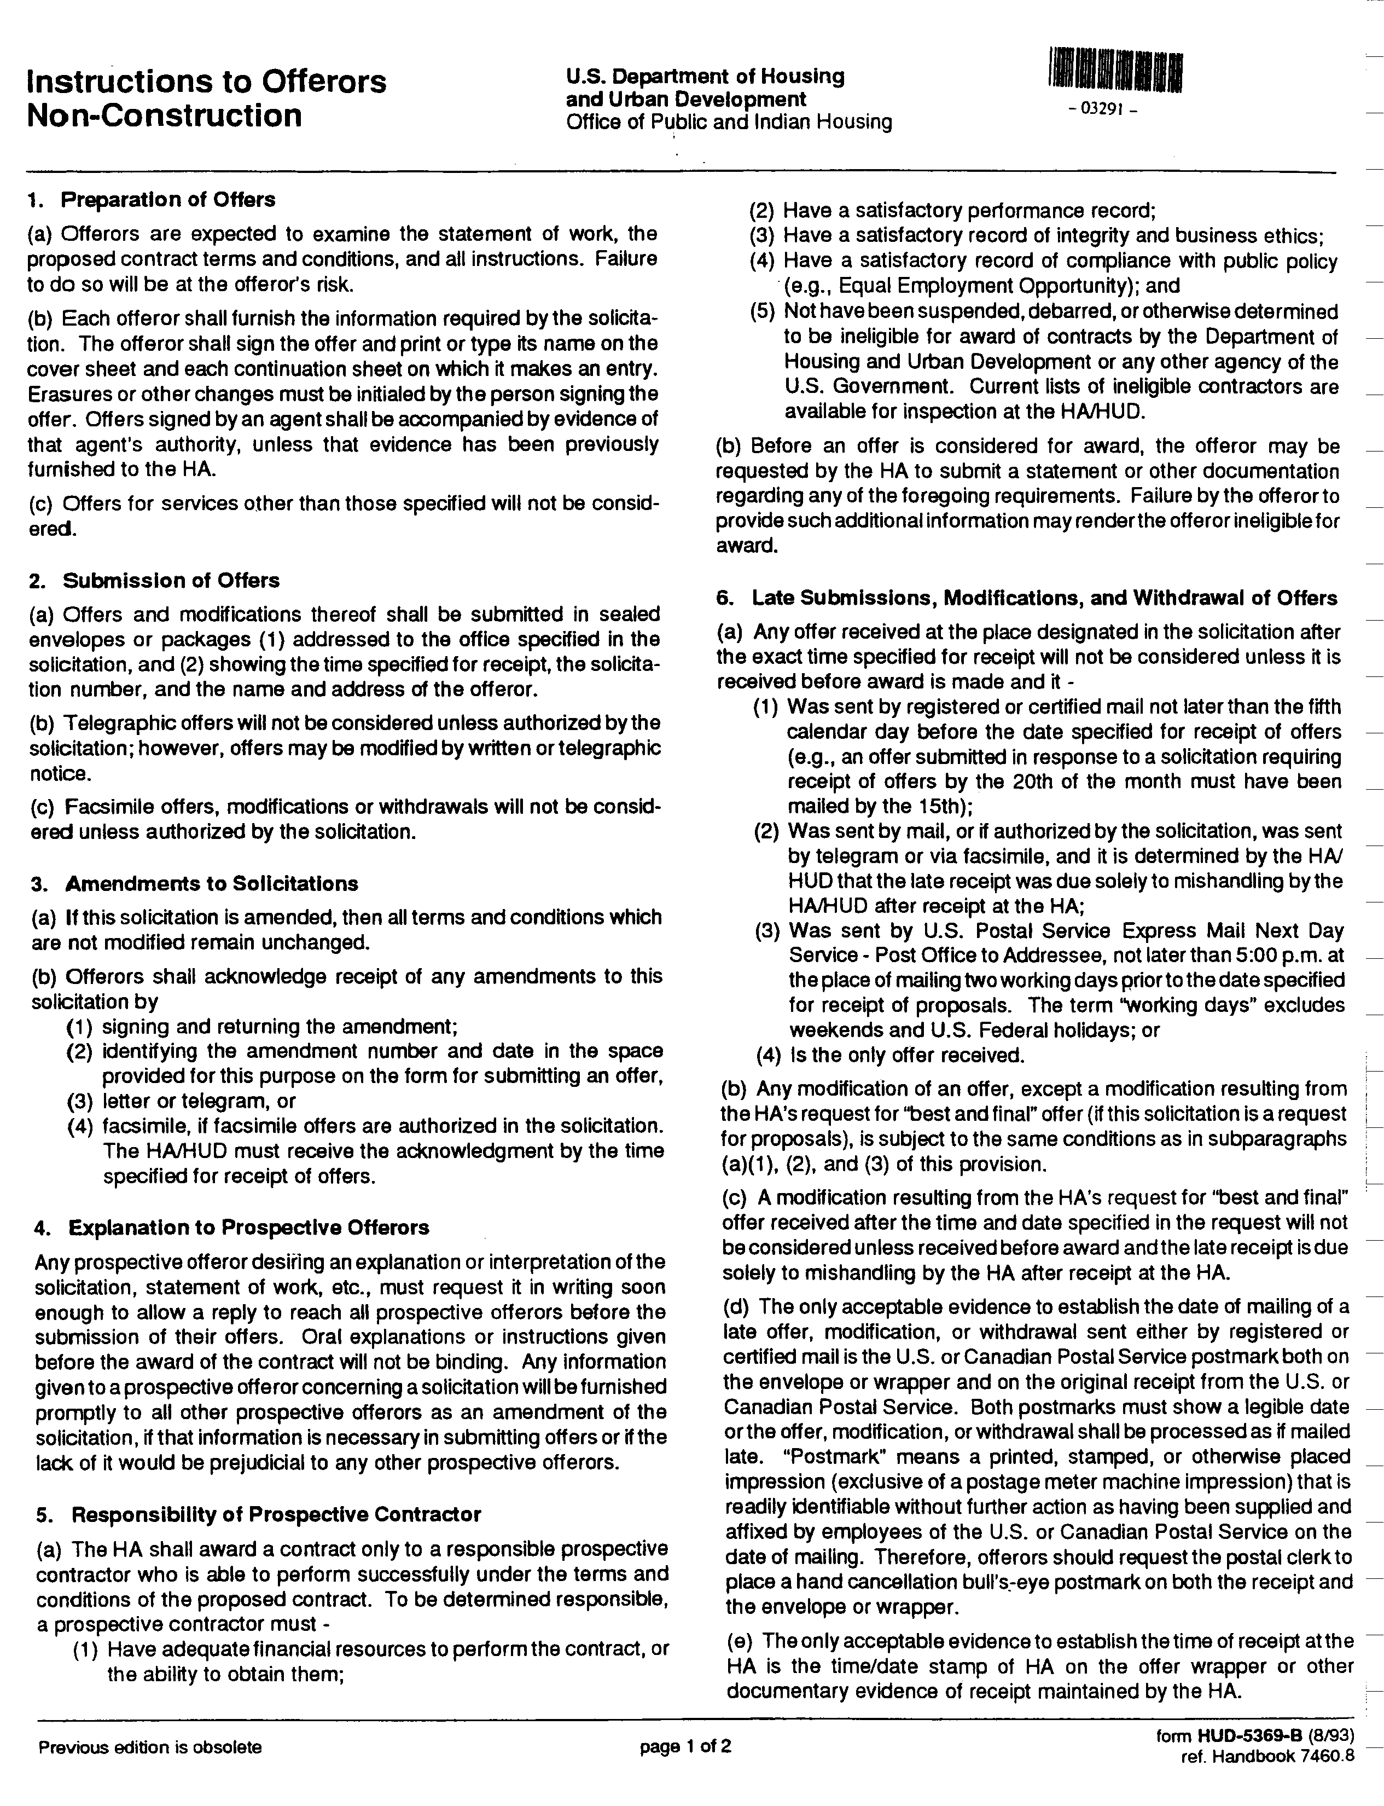

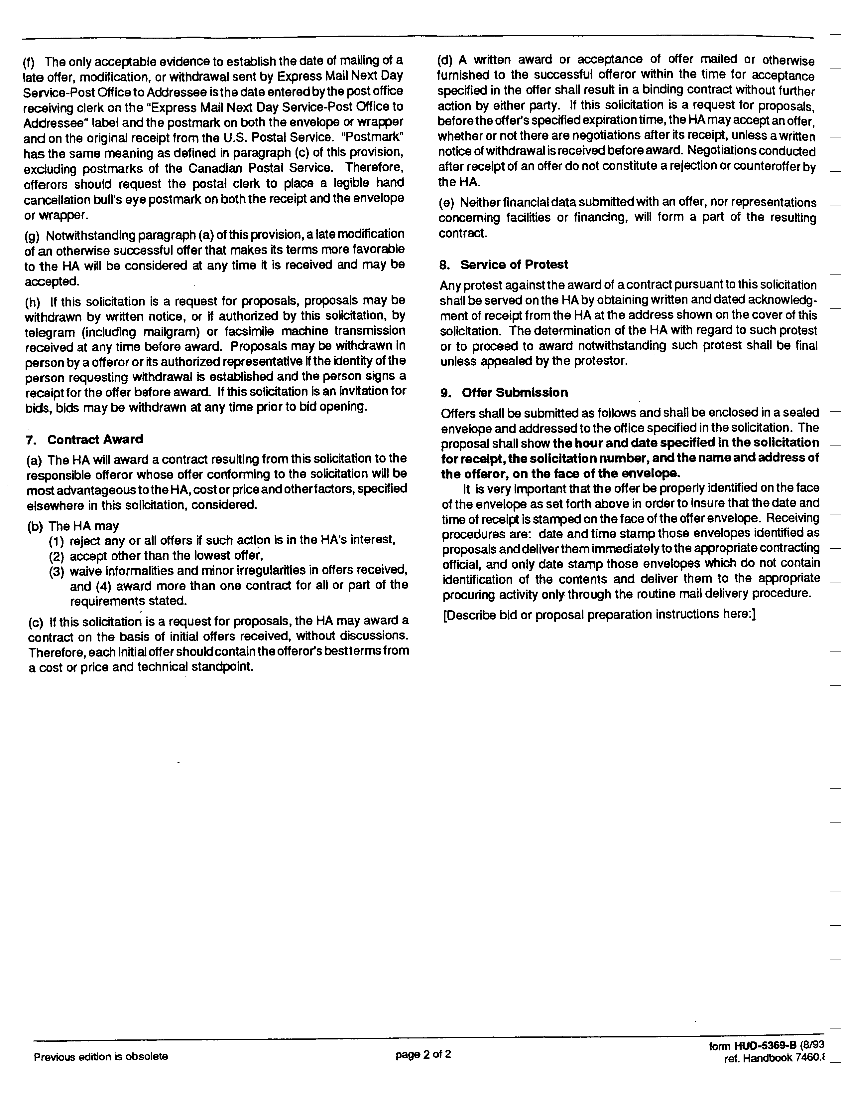

Form of Contract

For Electrical Repair Services

This AGREEMENT made this ____ day of _____________ in the year ______ by and between

(Name of Contractor)
(Address)

hereinafter called the "Contractor,” and the

Housing Authority of the Borough of Highlands
215 Shore Drive, Highlands, New Jersey 07732

hereinafter called the "Authority".

WITNESSETH that the Contractor and the Authority for the consideration stated herein mutually agree as follows:

Article 1. Statement of Services. The Contractor shall furnish all labor materials, tools and equipment and shall perform and complete all work required for electrical repair and non-routine electrical maintenance services at Jennie Parker Manor and Ptak Towers, Highlands, New Jersey.

Article 2. Term of Contract. This contract shall extend for a period of two years, July 1, 2025 to June 30, 2027. The contract shall be renewable for one additional two-year period at the agreement of both parties and at the same rates stated in Article 3 below.

Article 3. Performance of Work. The Authority shall have the sole right and discretion to order work under his contract The Authority reserves the right to award work of a similar nature, through other procurement methods, to other contractors.

Work shall be performed by the Contractor on an as-needed basis. The Authority makes no representation as to the amount of work that may be required during the contract period.

The Authority shall notify the Contractor of all work to be performed by means of a written work order. The Contractor shall be entitled to a minimum payment of two (2) hours labor charges for each completed work order. Labor charges shall be calculated based upon actual time spent at the housing project work site. No charges shall be made for travel or shop time. Fractions of hours shall be rounded up to the next hour.

Typically, work shall be performed during the Authority’s standard business hours. However, the Contractor shall be available to respond to emergency work order requests during non-business hours.

The Contractor may perform or complete non-emergency work orders outside of standard business hours for the Contractor’s convenience only if the Authority grants prior permission. For work performed under such circumstance, the Contractor will be compensated at the standard labor rates stated in Article 5 below.

The Contractor shall respond to an emergency work order within twenty-four (24) hours of the receipt of written notification and shall respond to a non-emergency work order within seventy-two (72) hours of written notification.

The Contractor shall be equipped to perform the work with all tools and equipment ordinarily and incidentally used in the performance of commercial electrical installations and repairs. If specialized equipment is required to perform a work order, the Contractor shall so notify the Authority. The Contractor shall obtain the Authority’s approval for the use and applicable charges for such equipment prior to the Contractor’s commencement of the work order or the Contractor’s procurement of equipment.

The Authority, at its discretion, may request an estimate from the Contractor of the labor and materials required to perform a work order. Estimates shall be provided at no cost to the Authority.

Upon completion of each work order, the Contractor shall present the completed written work order, indicating the actual time spent and materials used, to a designated representative of the Authority.

Article 4. Work Requirements and Contractor’s Responsibility. The Contractor shall be responsible for furnishing all materials, equipment, labor and transportation necessary to perform electrical repairs and non-routine electrical maintenance work.

All electrical work shall be performed in accordance with federal, State, County and local statutes, regulations and codes presently established or as may be established during the term of this contract. If the Contractor performs any work contrary to any federal, State, County or local statute, ordinance, regulation or code, he shall assume full responsibility and shall bear any and all costs attributable thereto

The Contractor must hold a valid and current New Jersey Electrical Contractor’s License. In the event that such license is revoked, suspended or expires during the term of this contract, the contract shall be terminated effective the same date as such revocation suspension or expiration.

All workers employed by the Contractor to perform electrical work must work under the direct supervision of a licensed electrician. Laborers shall not be permitted to perform any electrical work.

The Contractor shall be responsible to apply for and secure any and all permits required by governing authorities to perform the work.

The Contractor shall be responsible for all materials delivered and work performed until completion and acceptance of each work order.

The Contractor shall not sub-contract any work under this contract without express prior written approval of the Authority.

The Contractor shall at all times keep the work area orderly and free from accumulations of waste materials. After completing each work order, the Contractor shall remove all equipment materials and tools that are not the property of the Authority and leave the work area in a neat, clean and orderly condition.

The Contractor shall be responsible for all damages to persons or property that occur as a result of the Contractor’s fault or negligence, and shall take all necessary health and safety precautions to protect the work, the workers, the public, and the property of others. The Contractor shall hold and save the Authority, its officers and agents, free and harmless from liability of any nature occasioned by the Contractor’s performance.

Article 5. Labor Rates and Payments. The Authority shall pay the Contractor for work at the rates shown below. The rates shall be inclusive of all costs for labor, tools and equipment. The Authority shall also reimburse the Contractor for the actual cost of materials and approved specialized equipment plus a mark-up of ten percent (10%) of these costs.

The Authority shall pay the Contractor for work performed during the Authority’s business hours, Monday to Friday, 7:00 a.m. to 4:30 p.m., exclusive of holidays, at the following rates.

Standard Labor Rates

Electrician: ______________________________ dollars and ________ cents ($__.__) per hour.
Laborer: ________________________________ dollars and ________ cents ($__. __) per hour.

The Authority shall pay the Contractor for work performed at all other times at the following rates, unless work is performed at such times for the Contractor’s convenience.

Premium Labor Rates:

Electrician: ______________________________ dollars and ________ cents ($__.__) per hour.
Laborer: ________________________________ dollars and ________ cents ($__. __) per hour.

The Contractor shall submit an invoice by no later than the 10th day of each month for all work orders completed during the previous month. The invoice must be accompanied by completed work orders signed by a representative of the Authority, and paid receipts for material and approved specialized equipment costs.

The Authority shall make payments not more frequently than monthly upon the completion of work by the Contractor and the presentation of an invoice. Payment shall be due within 30 days of receipt of the invoice by the Authority.

Article 6. Insurance. Before performing any work, the Contractor shall furnish the Authority with certificates of insurance showing the following insurance is in force and will insure all operations under the Contract:

- Workers’ Compensation, in accordance with New Jersey Workers' Compensation laws.
- Commercial General Liability with a combined single limit for bodily injury and property damage of not less than $2,000,000.00 per occurrence to protect the Contractor and the Authority against claims for bodily injury or death and damage to the property of others. This shall cover the use of all equipment, hoists, and vehicles on the site(s) not covered by Automobile Liability under (3) below. If the Contractor has a “claims-made” policy, then the following additional requirements apply: the policy must provide a “retroactive date” which must be on or before the execution date of the Contract, and the extended reporting period may not be less than five years following the completion date of the Contract.
- Automobile Liability on owned on owned and non-owned motor vehicles used on the site(s) or in connection therewith for a combined single limit for bodily injury and property damage of not less than $500,000.000 per occurrence.

All Insurance shall be carried with companies which are financially responsible and admitted to do business in the State of New Jersey. If any such insurance is due to expire during the construction period, the Contractor shall not permit the coverage to lapse and shall furnish evidence of coverage to the Authority. All certificates of insurance, as evidence of coverage, shall provide that no coverage maybe canceled or non-renewed by the insurance company until at least 30 days prior written notice has been given to the Authority.

Article 7. New Jersey Business Registration Requirements. The contractor shall provide to the Authority proof of the contractor’s business registration with the New Jersey Division of Taxation. This document is required component of the bid package. Bids received without the business registration is considered a non-waivable defect and the bid will be rejected.

The contractor shall provide written notice to its subcontractors and suppliers of the responsibility to submit proof of business registration to the contractor. The requirement of proof of business registration extends down through all levels (tiers) of the project.
Before final payment on the contract is made by the Authority, the contractor shall submit an accurate list and the proof of business registration of each subcontractor or supplier used in the fulfillment of the contract, or shall attest that no subcontractors were used.
For the term of this Agreement, the contractor and each of its affiliates and a subcontractor and each of its affiliates [N.J.S.A. 52:32-49(g)(3)] shall collect and remit to the Director, New Jersey Division of Taxation, the use tax pursuant to the Sales and Use Tax Act on all sales of tangible personal property delivered into this State, regardless of whether the tangible personal property is intended for a contract with a contracting agency.

A business organization that fails to provide a copy of a business registration as required pursuant to section 1 of P.L. 2001, c.34 (C.52:32-44 et al.) or subsection e. or f. of section 92 of P.L. 1977, c.110 (C.5:12-92), or that provides false business registration under the requirements of either of those sections, shall be liable for a penalty of $25 for each day of violation, not to exceed $50,000 for each business registration copy not properly provided under a contract with a contracting agency.

Article 8. Contract Documents. Contract Documents shall consist of the following component parts:

- This instrument;
- General Conditions for Non Construction Contracts, form HUD-5370-C II; and
- Addenda (if any).

This instrument together with the document enumerated in this Article form the Contract, and they are fully a part of the Contract as if hereto attached or herein repeated. In the event that any provision in one of the component parts of the Contract conflicts with any provision of any other component part, the provision in the component part first enumerated in this Article 8 shall govern, except as otherwise specifically stated.

IN WITNESS WHEREOF, the parties hereto have caused this instrument to be executed the date and year first above written.

In the presence of:

________________________________ by_______________________________________
(Name)
(Title)
(Company Name)
(Phone Number)
In the presence of:

_________________________________ by______________________________________
Douglas G. Dzema, PHM
Executive Director
Housing Authority of the Borough of Highlands

Description of the Housing Project Sites

Development Name: Jennie Parker Manor
Address: Highlands, NJ
Number of Buildings: 3
Building Type: Wood Frame Brick Veneer and Vinyl Siding
Row House and Walk-Up Apartments
Date of Construction: 1954
Number of Dwelling Units and Sizes:
1-Bedroom: 2; 2-Bedroom: 18; 3-Bedroom: 8; 4-Bedroom: 2

Development Name: Ptak Towers
Address: 215 Shore Drive, Highlands, NJ
Number of Buildings: 1
Building Type: Concrete Frame, Elevator Building
Date of Construction: 1986
Number of Dwelling Units and Sizes:
1-Bedroom: 95
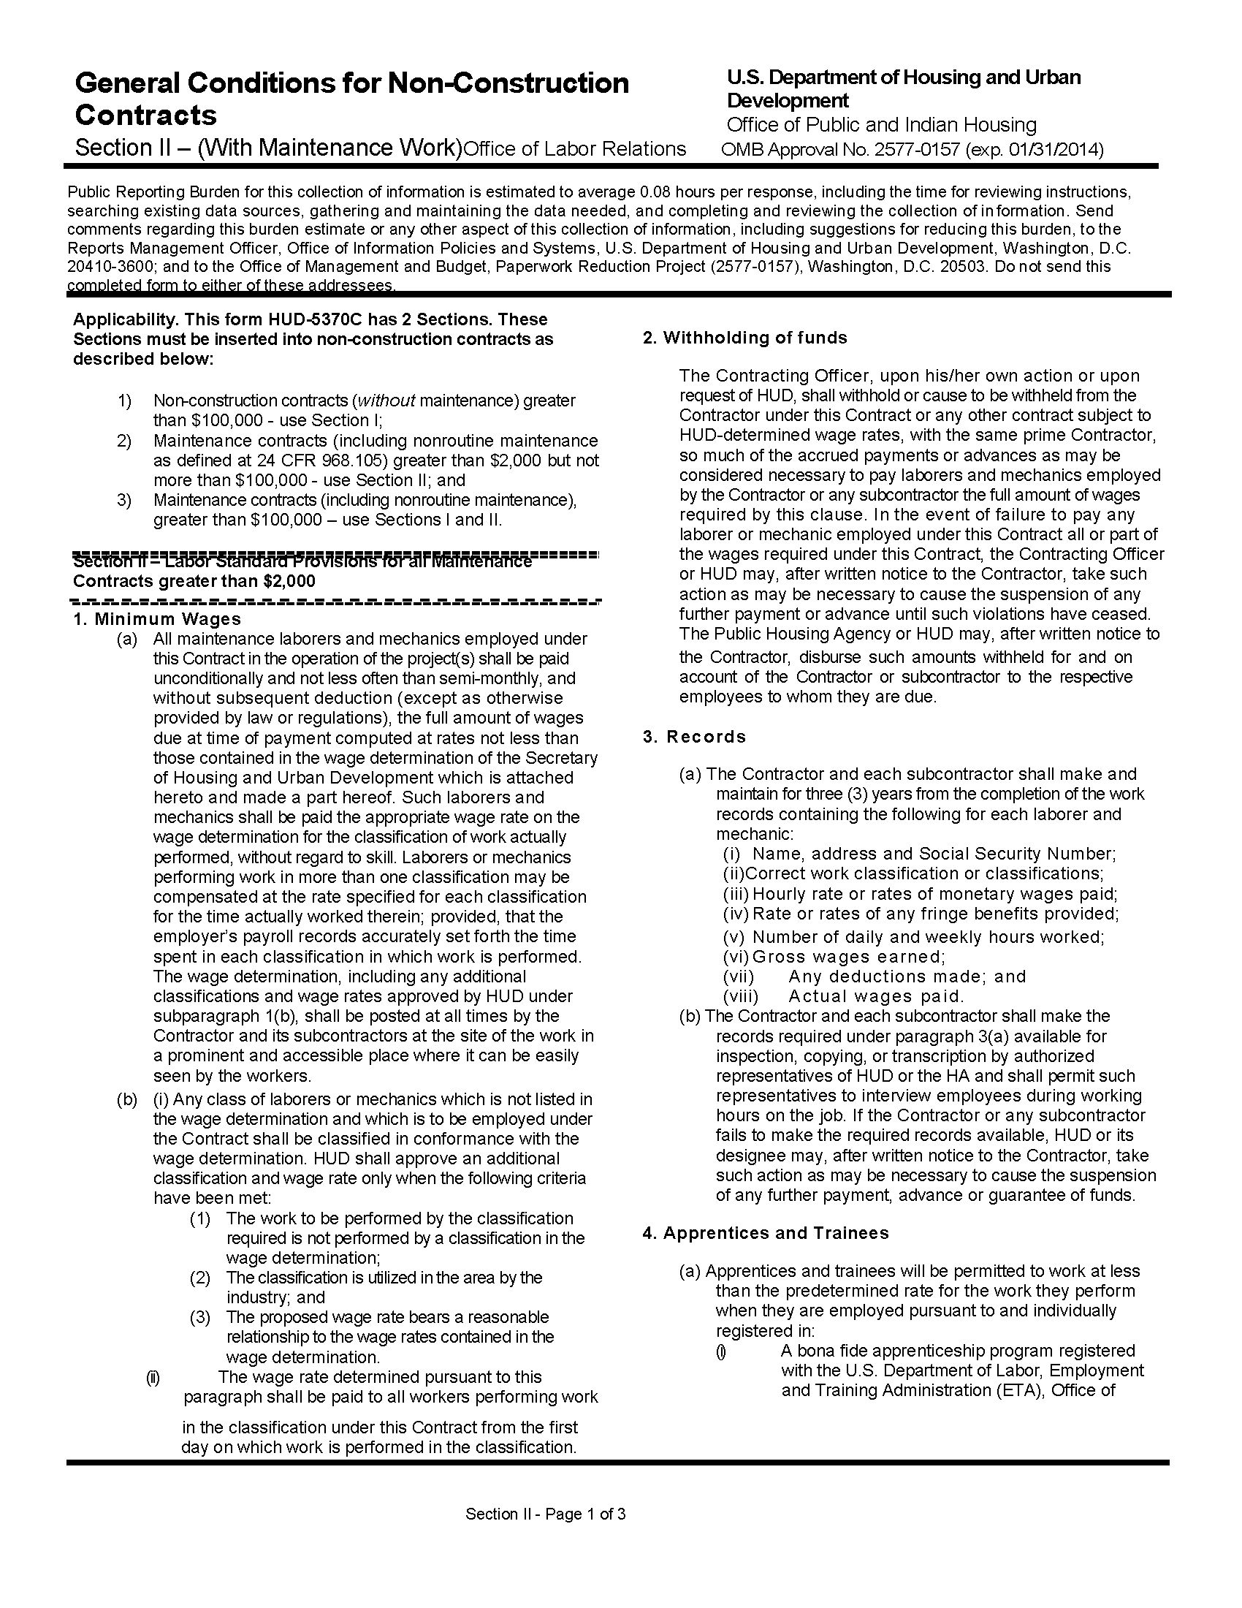

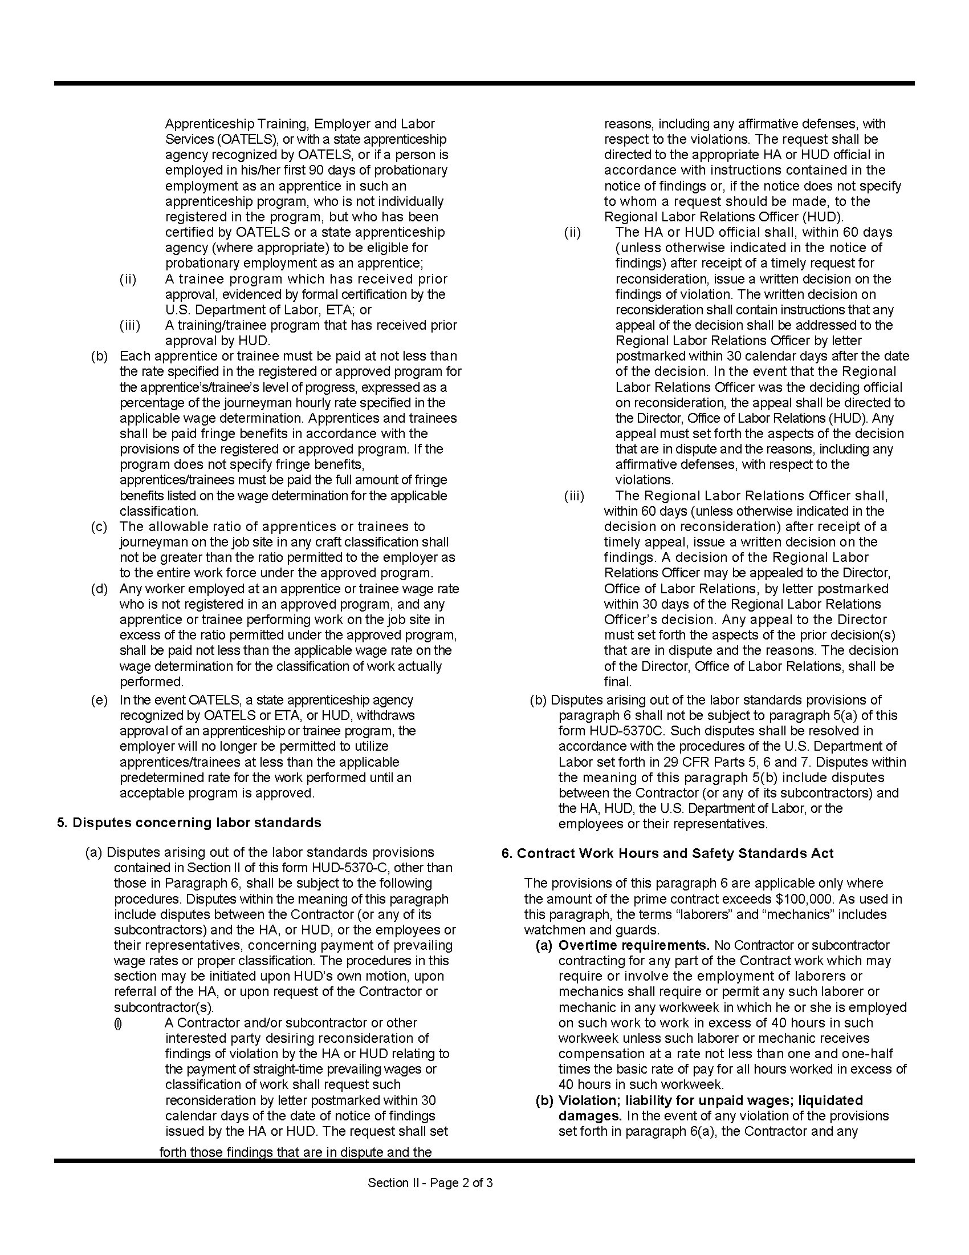

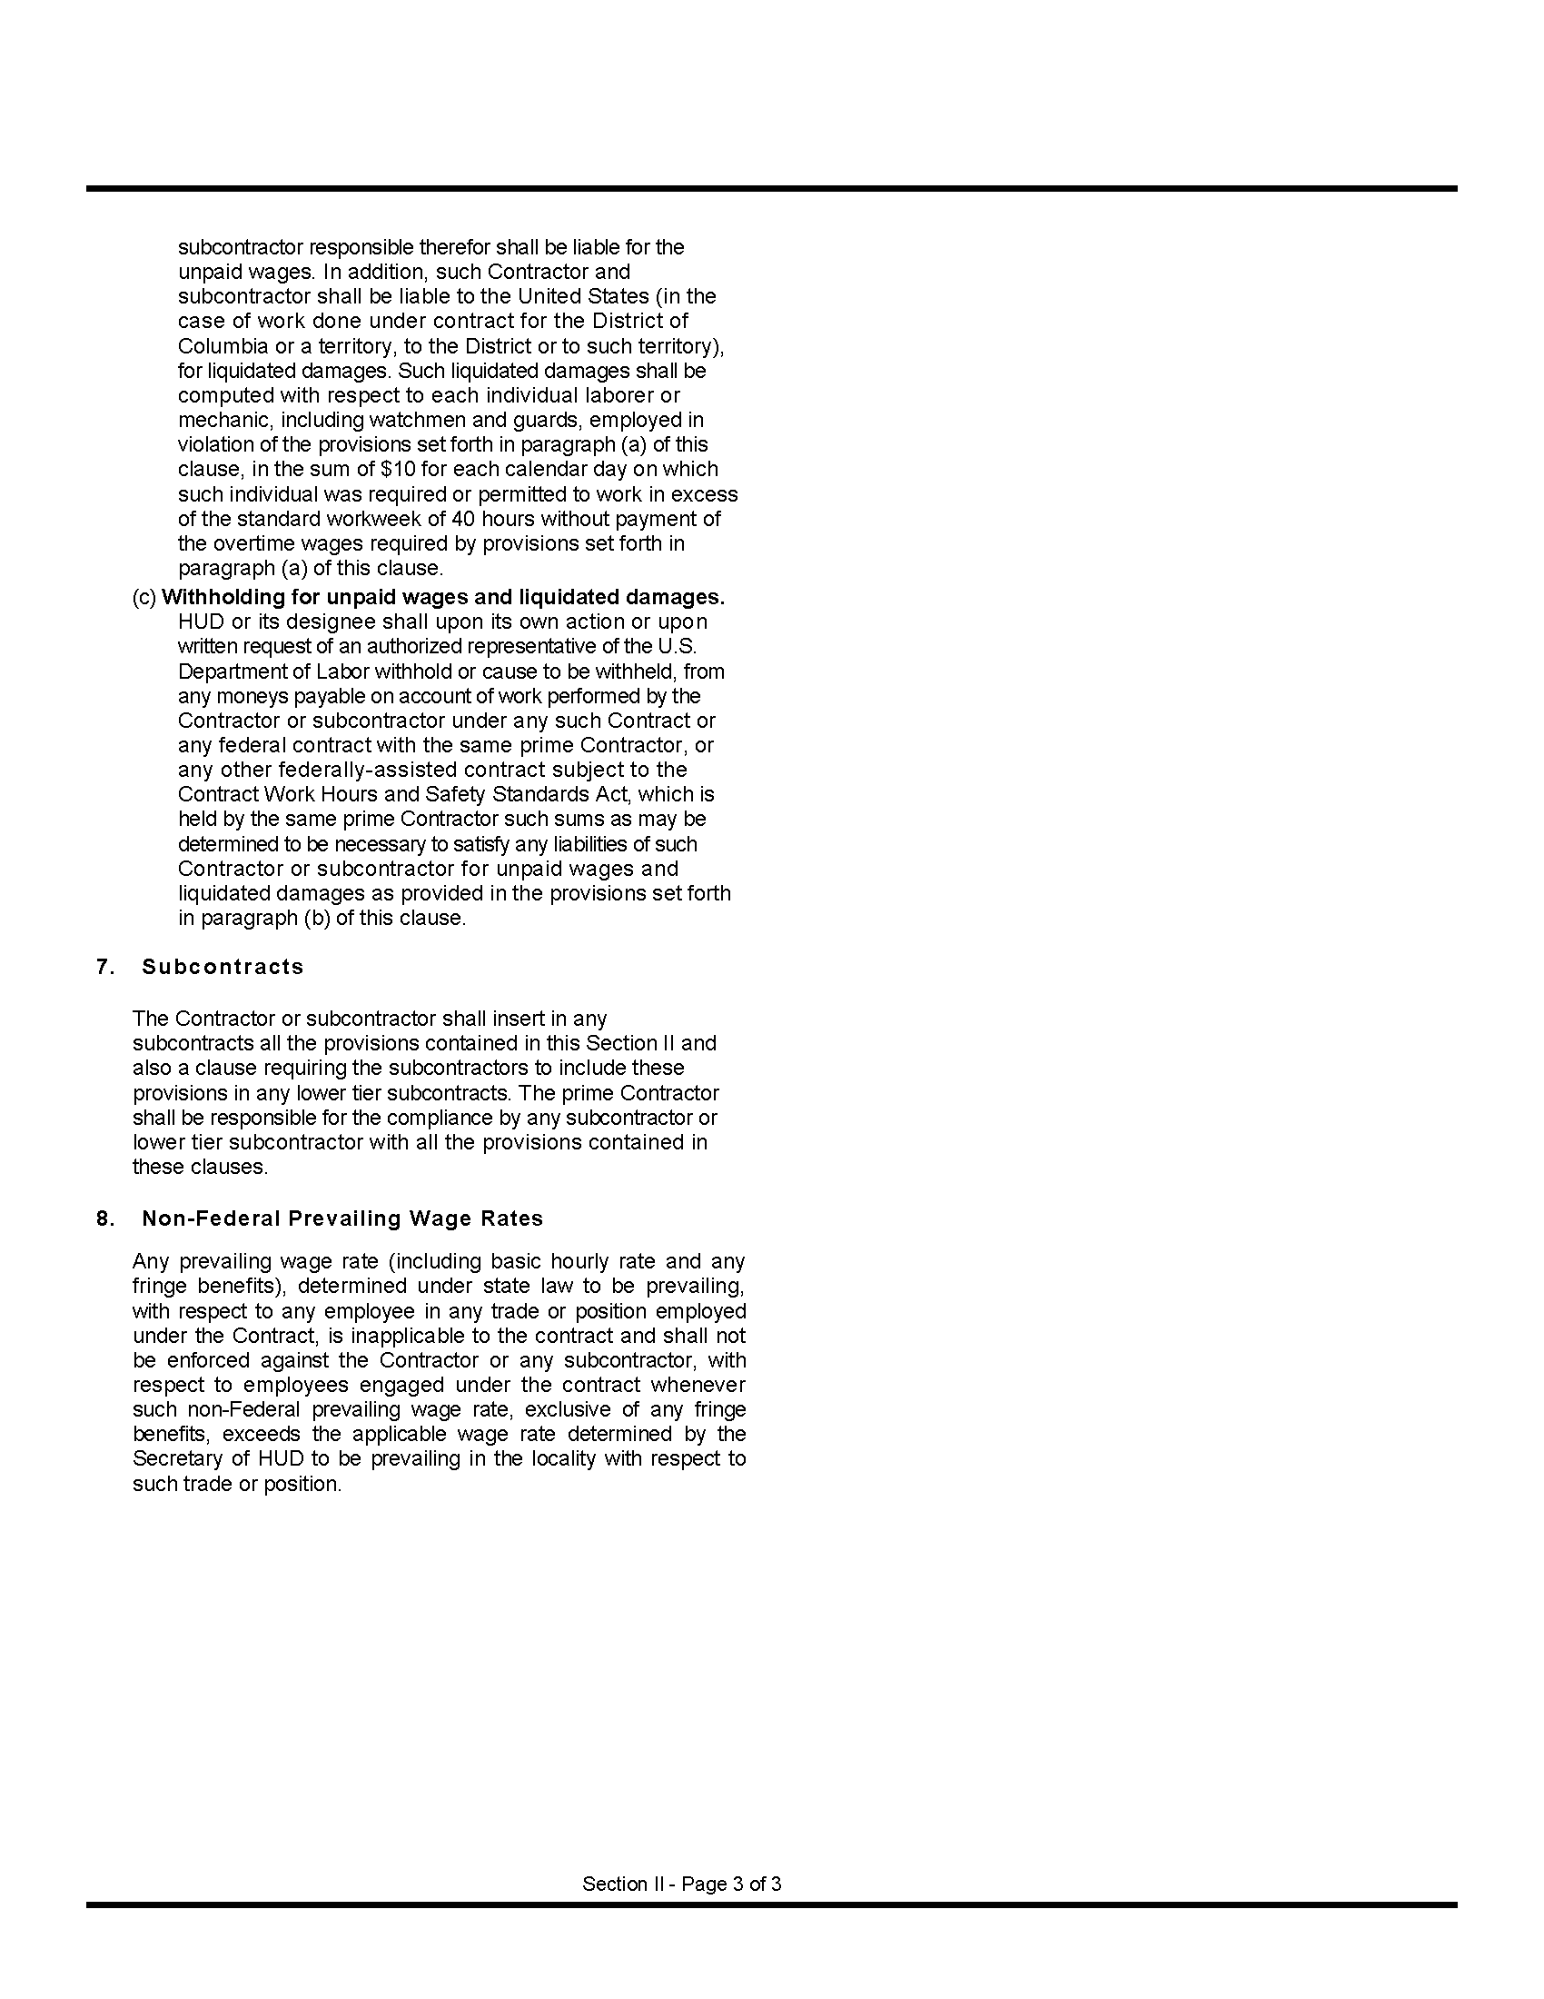

Proposal

Proposal for: Electrical Repair and Non-Routine Electrical Maintenance Services

TO: Housing Authority of the Borough of Highlands
215 Shore Drive, Highlands, New Jersey 07732

FROM:
______________________________________________________________________________
Company Name of Bidder
______________________________________________________________________________
Address
______________________________________________________________________________
Federal ID#
______________________________________________________________________________
Contact Name and Title
______________________________________________________________________________
Phone / Fax/Email Address

1. The undersigned, having read the Specifications, including the Instructions to Offerors, Request for Proposals, the form of contract, this proposal form, the Certifications and Representations of Offerors, the form of non-collusive affidavit, the form of statement of offeror's qualifications, and addenda, if any, thereto, and having investigated the local conditions affecting the cost of the work, hereby propose to furnish all labor, materials, services, equipment and related items to complete all work for electrical repair and non-routine electrical maintenance services in accordance therewith at the following labor rates:

Electrician, Standard Rate:

______________________________________________dollars and _______ cents ($___.___) per hour.

Laborer, Standard Rate:

______________________________________________dollars and _______ cents ($___.___) per hour.

Electrician, Premium Rate:

______________________________________________dollars and _______ cents ($___.___) per hour.

Laborer, Premium Rate:

______________________________________________dollars and _______ cents ($___.___) per hour.

2. The offeror acknowledges the receipt of the following addenda, if any, issued by the Authority:
Addendum Number __________ dated ___________________________
Addendum Number __________ dated ___________________________

3. The names and address of persons interested as principals or as stockholders in this Proposal are as follows. (If the offeror is a corporation or partnership, list all persons who have 10 percent or more ownership in the corporation or partnership.)

______________________________________________________________________________
Full Name Address % of ownership
______________________________________________________________________________
Full Name Address % of Ownership
______________________________________________________________________________
Full Name Address % of ownership
______________________________________________________________________________
Full Name Address % of ownership

Attach additional pages, if needed.

The offeror shall state on the line below, whether or not he is a citizen of the United States, and in the case of a partnership, whether or not all partners are citizens of the United States.

____________________________________________________________________________________

4. This Proposal is accompanied by:

(1) Form HUD-5369-C, Certifications and Representations, of Offerors, Non-Construction Contract;
(2) Non-Collusive Affidavit;
(3) Qualification Questionnaire.
(4) Copy of New Jersey Business Registration Certificate, issued by the New Jersey Department of the Treasury, Division of Revenue.
Note: The Certificate of Authority to collect New Jersey sales & use tax, issued by the New Jersey Department of the Treasury, Division of Taxation is NOT an acceptable substitute for this document.

Note: The above documents, together with this proposal form, are required by federal regulation or New Jersey law to be submitted with the bid. Failure to submit or complete any of the items listed above at the time of bid opening will result in disqualification of the bid

5. In submitting this proposal, it is understood that the Housing Authority of the Borough of Highlands reserves the right to reject any and all offers. If written notice of the acceptance of this proposal is mailed, telegraphed or delivered to the undersigned within 60 days after the opening thereof, or at any time thereafter before this offer is withdrawn, the undersigned agrees to execute and deliver a Contract in prescribed form within 10 days after the contract is presented to him for signature.

AFFIDAVIT

State of ______________________________
SS.
County of ____________________________

________________________________ being first duly sworn deposes and says:
(Individual’s name)

THAT he is ___________________________________________________________________,
(Owner, Officer or Partner of the firm of etc.)

the party making the foregoing proposal for electrical repair services at Jennie Parker Manor and Ptak Towers, Highlands, New Jersey; that all statements contained in this proposal are true, accurate and complete.

________________________________________________
(Signature of Offeror)

Subscribed and sworn to before me, this ____ day of ____________________ in the year _____.

________________________________________________
Notary Public
My Commission expires _________________________
Date
Non-Collusive Affidavit

AFFIDAVIT

State of ________________________

County of ______________________

___________________________________________________ being first duly sworn deposes and says:
(Individual’s Name)

THAT he is ________________________________________________________________________ of
(Owner, Officer or Partner)

____________________________________________________________________________________
(Firm Name)

the party making the foregoing proposal dated ____________________ for electrical repair and non-routine electrical maintenance services; that such proposal is genuine and not collusive or sham; that the offeror has not colluded, conspired, connived or agreed, directly or indirectly, with any offeror or person, to put in a sham proposal or to refrain from offering a proposal, and has not in any manner, directly or indirectly, sought by agreement or collusion, or communication or conference with any person, to fix the proposed prices of affiant or of any offeror, or to fix any overhead, profit or cost element of said proposed prices, or of that of any other offeror, or to secure any advantage against the Housing Authority of the Borough of Highlands or any person interested in the proposed contract; and that all statements in the said proposal are true.

________________________________________________
(Signature of Offeror)

Subscribed and sworn to before me, this ______ day of _________________, in the year ___________

____________________________________________________
Notary Public

My Commission expires __________________

Qualification Questionnaire

Proposal for: Electrical Repair and Non-Routine Electrical Maintenance Services

Name of Offeror: _____________________________________________________________________

Address:_____________________________________________________________________________

____________________________________________________________________________________

(a) It shall be necessary for the offeror to present evidence that he has been in business for at least 3 years in this field and can submit a suitable record of satisfactorily completing similar contracts.

How many years have you been or engaged in business under your present firm or trade name?

________________Years.

(b) How many years has your organization been performing the work required under this contract?

________________Years.

(c) If a corporation, answer the following:

Date of incorporation: __________________________________________________________________

State of Incorporation: __________________________________________________________________

President's Name: _____________________________________________________________________

Vice President's Name(s):_______________________________________________________________

(d) If a partnership, answer the following:

Date of Organization:___________________________________________________________________

(e) New Jersey Electrical Contractor license number and effective date:

____________________________________________________________________________________

(f) List employees holding New Jersey Electrician Licenses and effective dates:

____________________________________________________________________________________

____________________________________________________________________________________

(g) If the contract is awarded to your firm, who will personally supervise the work?

____________________________________________________________________________________

(h) Are there any liens of any character filed against your company at this time? If so, specify the nature and amount of the lien.

____________________________________________________________________________________

(i) Give trade references:
____________________________________________________________________________________

____________________________________________________________________________________

(j) Give bank references:
____________________________________________________________________________________

____________________________________________________________________________________

(j) Give full information concerning all of your contracts in progress or completed within the last 3 years, whether private or government contracts.

OWNER/LOCATION DESCRIPTION CONTRACT AMOUNT

____________________________________________________________________________________

____________________________________________________________________________________

____________________________________________________________________________________

____________________________________________________________________________________

State of ________________________

County of ______________________

___________________________________________________ being first duly sworn deposes and says:
(Individual’s Name)

THAT he is ________________________________________________________________________ of
(Owner, Officer or Partner)

____________________________________________________________________________________
(Firm Name)

and that he hereby authorizes and requests any person, firm or corporation to furnish any information requested by the Housing Authority of the Borough of Highlands in verification of the recitals comprising this Statement of Offeror's Qualification; and that all answers to the foregoing questions and all statements therein contained are true and correct.

________________________________________________
(Signature of Offeror)

Subscribed and sworn to before me, this ______ day of _________________, in the year ___________

____________________________________________________
Notary Public

My Commission expires __________________

